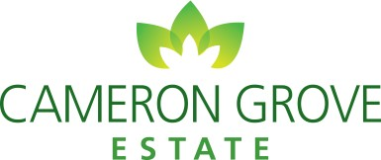
Refer a friend to Cameron Grove Estate

If your friends love coming over, why not invite them to stay? Refer a friend you would love to live closer to,
if they decide to purchase and join the Cameron Grove community you can each receive a $1000 Visa Gift Card*.

Next steps?
- Complete and sign this referral form on the back with your friend.
- Your friend can then take this completed form to Cameron Grove Estate Sales Office.
- Once your friend settles on their purchase you will each receive a $1000 Visa Gift Card.

Your details:

Full Name:
Address:
Phone: Email:
Signature:

Your friend’s details:

Full Name:
Address:
Phone: Email:
Signature:

*Incentive is a $1000 Visa Gift Card. Promotion only applies to qualifying land at Cameron Grove Estate. Eligible referred participants will each receive a $1000 Gift Card. The referrer must be a current resident at the time of submission. Not to be used in conjunction with any other promotion. Gift card will be issued at settlement.

